**Report 1: Temporal Analysis**

Summary

The purpose of this report is to provide deeper insights to when instances of domestic violence (DV) occur. This report considers different timeframes to analyze the frequency of DV over the course of 2021, by month and seasons throughout the year, by the days of the month and seasons, and even by the hour of the day.

Descriptive Analysis

Each figure has a corresponding tabular format attached at the end of the report.

Figure 1

DV daily distribution per month


Figure 1 shows the distribution of DV instances per the 12 months. Each data point considered is the number of DV instances that occurred on that given day. For example, the median daily number of occurrences in January was just over 150, whereas the max daily frequency for January was 303 instances reported. Table 1 contains the data that was used for this plot. Below are the descriptive statistics for this data distribution.

Figure 2

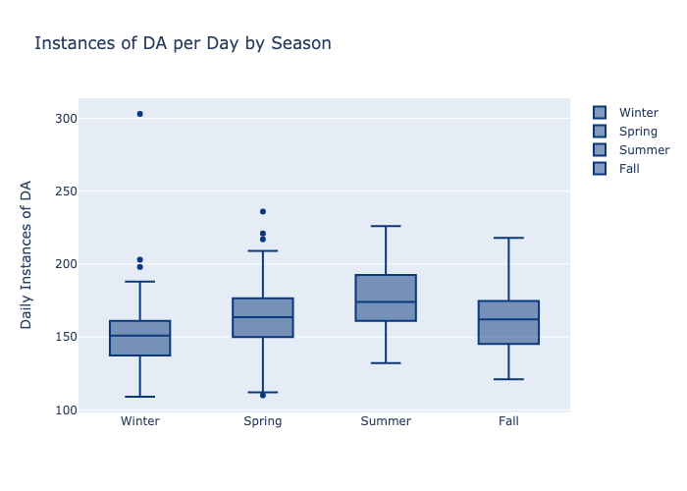

Figure 2 contains the same data as figure 1; however, the data are grouped here by season rather than by month. Below are the descriptive statistics for this data distribution.

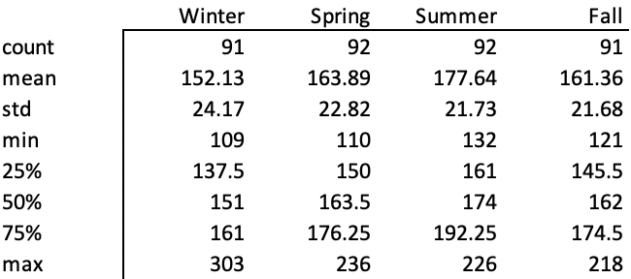

The count indicates that totals were aggregated for 31 different days in each season. I.e., the sum of each 1st of the month during winter was added to the data points for winter, and so on.

Figure 3

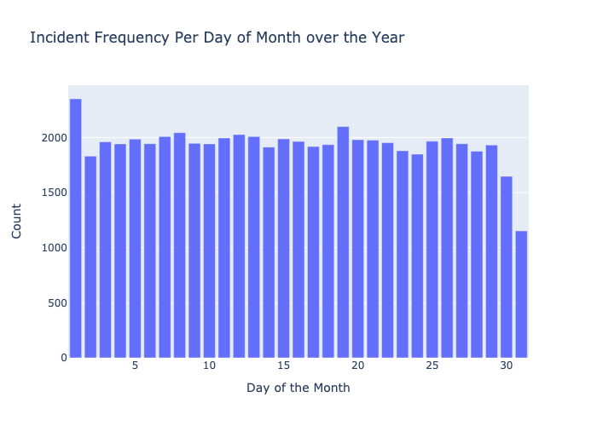

Figure 3 illustrates the frequency of date that DV occurred on. There is a dip on the 31st of the months since roughly half the months do not have a 31st.

Figure 4

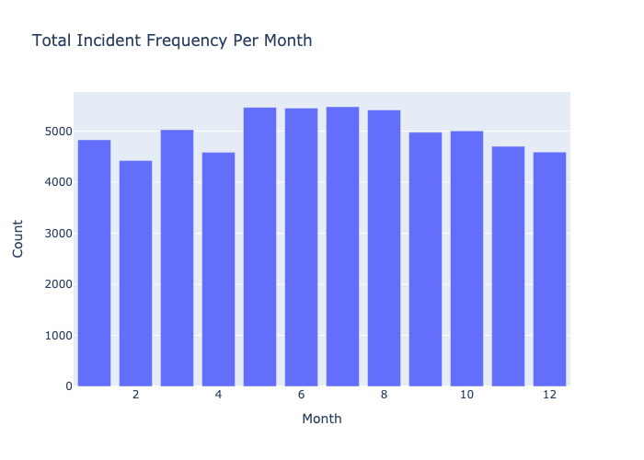

Figure 5

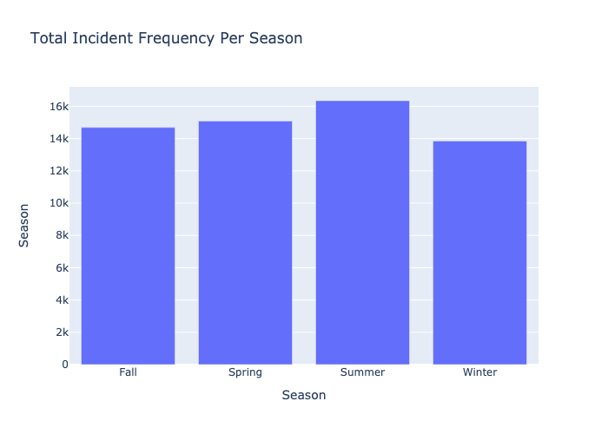

Figure 6

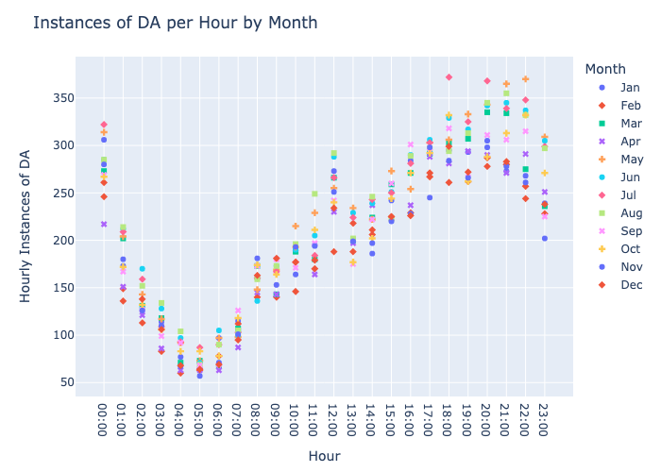

Figure 7



